Remembering the Tater ARG
By Partonetrain

This is a retelling of events that took place in the Violet Moon Discord Server from July to September 2021.
Note that many of the tweets and some of the relevant discord messages have been deleted. Officially, there was never a Tater ARG.

For some context, Tater is the nickname of the beloved block from the Botania mod, Tiny Potato, and the “mascot” of Violet Moon. For a period of time in 2021, many users were creating Tiny Potato memes, so much so that a text channel named #taterposting was created specifically for these memes. Many of these memes were crossposted to a Twitter account I ran (@taterposting). At the time, it was not public knowledge that I ran the taterposting account.

The Original Tater ARG

It all started on the afternoon of July 30th. Alwinfy (at my request) posted the latest @taterposting tweet:
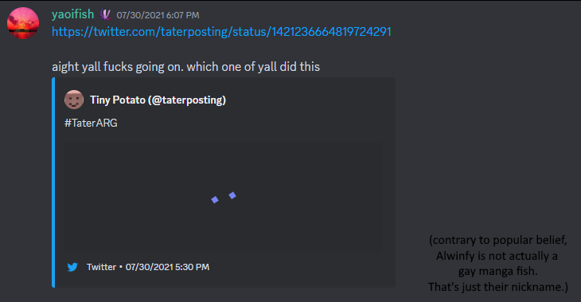

This tweet has been deleted, but contained an image describing an ARG centered around our Tater - with the first step of it being a physical item - the Tater Crate - having the instructions for the next step. It had been placed along a public roadway at the bottom of a place named Tater Hill immediately prior to the tweet. The Tater Crate was a metal lunch box with a paper Tater face attached to it. There were coordinates to the Tater Crate in the image. There was to be a physical reward for discovering the Crate, and a monetary (gift-card) reward for completing the ARG.

I highly doubted anyone would actually get the “Tater Crate” - although I was aware of multiple users in the server being located within day-trip distance, driving to effectively the middle of nowhere for some intangible object because someone in an internet community you’re in supposedly placed something there was outlandish. However, I did put effort into the contents of the crate and the first ARG, in case it did happen. The first ARG was essentially a series of Google Docs with questions relating to Botania - at least that’s what I remember of it.

Also, I suspected the crate wasn’t going to last long, as it was visible from the road. I imagined someone who hadn’t the faintest clue about Minecraft or Botania or Tater would find it and take it, thinking it was a geocache or something. So, not wanting my effort to go to waste, I thought it would be best to retrieve the crate myself, and continue the ARG in some other fashion.

On August 1st, I made my alt account - at the time, just named Nia - join the Discord server.
Nia posted some inane "new user" type messages, just to give the impression that it was a different person.

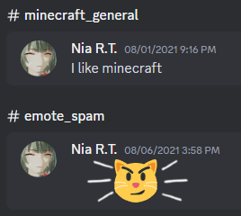

(More context: I had conceptualized an “alter ego” so to speak long before this, named Niartenotrap, which is just my username spelled backwards. This “alter ego” would use my favorite Xenoblade Chronicles 2 character, Nia, as its profile picture, since the first three letters of “Niartenotrap” are Nia.)

Then, on August 7th, I retrieved the crate myself and made my alt account claim it had found it:
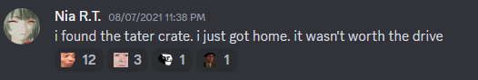

Some days later, a regular pinged Nia asking what was in the crate. Wanting to re-use the crate for something else later on, I posted as Nia:

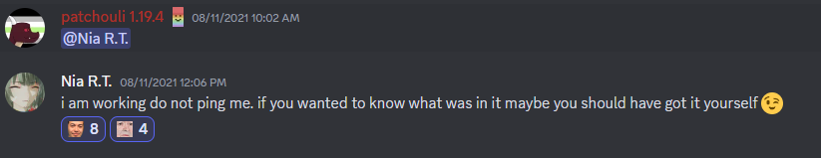

This whole setup, in essence, was designed to create drama, and create anticipation for the so-called “Tater ARG 2” which I teased (as my normal Discord user, Partonetrain) as an all-digital ARG after the first one had been solved. Admittedly, I had not totally thought out what Tater ARG 2 was to be when I was designing the first one. It was more of an experiment to see how many people I could get engaged in this project (and if anyone would actually get the crate, which, again, I doubted). Unfortunately, the fake-out of Nia not describing what was in the crate made some people upset. I genuinely felt bad about doing that, and I still think I could have handled it better. (I have apologized to those affected, but again, if I did that to you, I’m genuinely sorry. My intent was to create something fun the community could engage in, but I realize now it was a bit cruel).

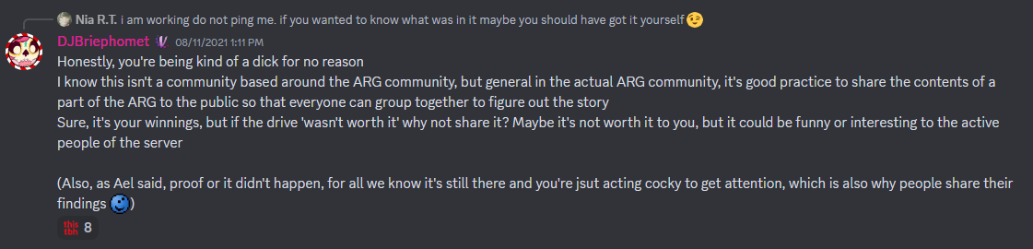

Regarding the doubt, I posted as my main account in the VIP chat that this Nia person was legitimately the winner of the ARG, and I knew they had the crate because they used the contents to win.

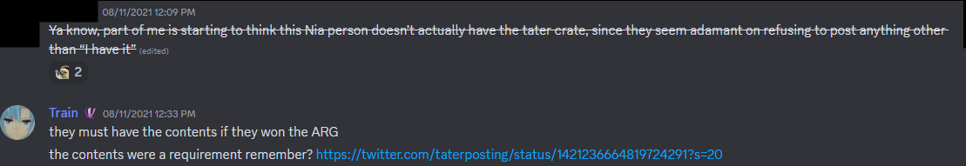

However, Kamefrede, one of our moderators, was on to me.

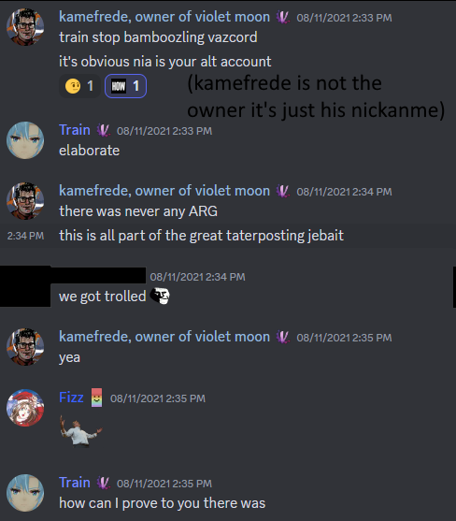

However, because I had indeed created the original Tater ARG, I was able to prove that there was a real Tater Crate. This got Kamefrede off my back.

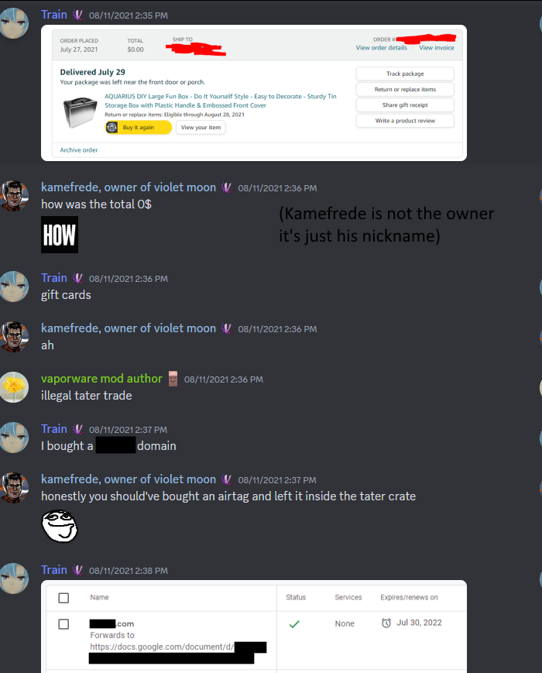

However, some users were still upset at this Nia character. I did not want any vitriol, so I (as Partonetrain) requested that the topic be dropped, and that everyone look forward to the all-digital Tater ARG 2. This request had mixed success but everyone eventually mostly forgot about it and Nia after she revealed the contents of the crate.
(Remember, this user’s display name was just “Nia” at the time).

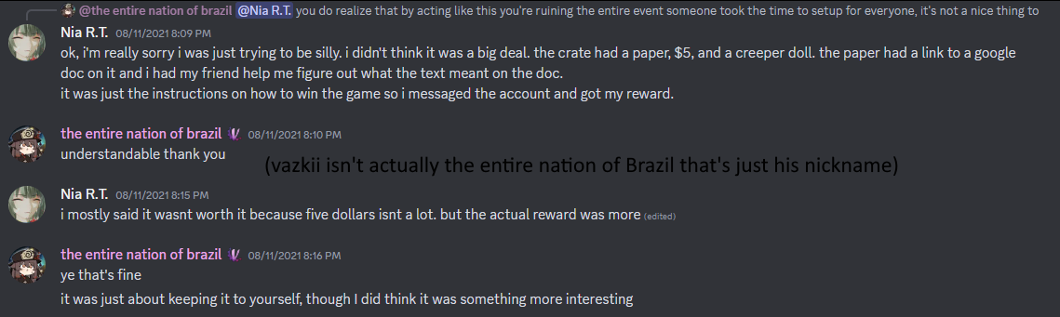

Tater ARG 2

About a month later, I launched the “Tater ARG 2”. A thread in the discord was immediately created, again by my request to Alwinfy.
The first step is actually something that wasn’t deleted. A link to the document pictured below can still be found in the thread. The links in this document are still up, but I implore you to not download anything yet, for reasons I will get into later.

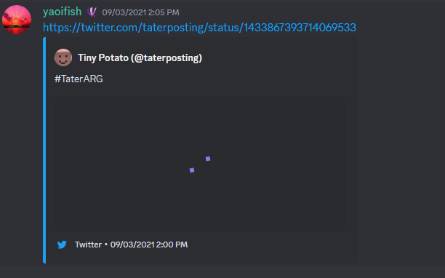

(deleted tweet, had an image which described a puzzle which resolved to a URL which redirected to the document pictured below):
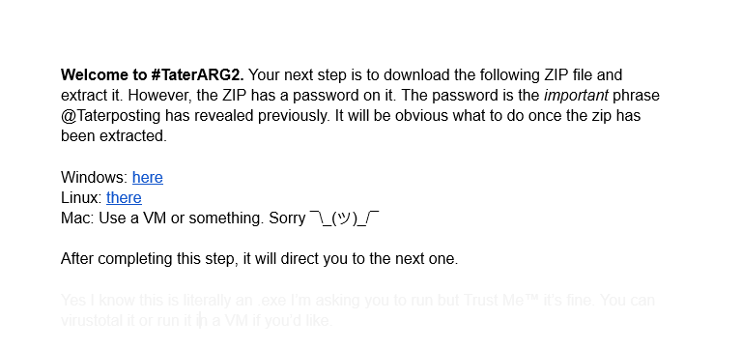

Step 2 was an intentionally very bad and designed-to-be-frustrating bullet hell kind of game featuring elements from Botania that I whipped up in Unreal Engine 4 over the course of August.
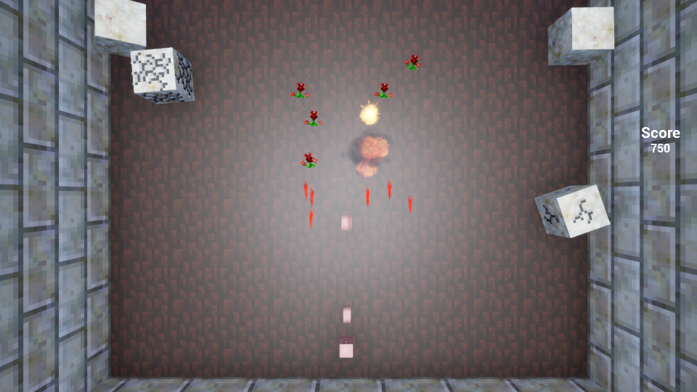
I titled it, Taterhou: Tenacious Daybloom, referencing Touhou Ten Desires. Mind you, I am not a bullet hell kind of person, but Touhou as a series has existed as part of the server’s culture (see the Patchouli mod), and an intentionally-bad bullet hell seemed simple enough to script in about a month.

You play as Tater and shoot smaller versions of yourself. The game has a few types of enemies. The Bellethorne and Bellethorne Petite shoot red bullets at you. The Rannuncarpus would place blocks (that are physics objects that get in the way of your own bullets). Finally, there was the boss, the Daybloom, coming back for revenge after having been removed from Botania, which shot bullets in all directions and moved up and down. It only took around 10 or so minutes to get to the Daybloom boss, but defeating it was very difficult because it required a lot of hits and had an unfair bullet pattern.

The game used some sound effects from Botania. The music that played was an ear-piercing automatically-converted MIDI version of the Gaia Guardian music.

Oh, and if you died (which happened if you got hit once), it showed you an overlay of the :dontfeelsowaaaaaaa: emote, and then the game closed, and you had to start over.

I designed it to only be beatable if you entered a cheat code by quickly typing it in. There were a few ways to win via cheat code: the Konami Code instantly won the game, entering “tater” made you shoot taters extremely fast making the game easy, and there was another code that I can’t remember that just made you invincible.

But of course, the players had not realized this yet:

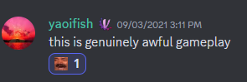

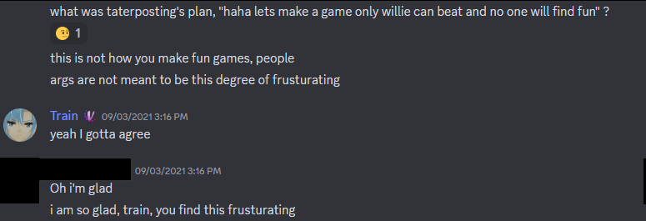

I have to admit, I was laughing so hard I couldn’t breathe at this point.

But then one of the Touhou players in the server actually beat it legitimately.

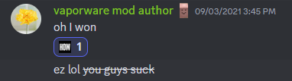

Enter MoriyaShiine. I genuinely believed the game to be impossible (without the cheat codes) so I had to DM him to check how he beat it. I did program the game to display a different ending screen if you somehow beat the game without cheat codes, but that part was bugged, so it had marked him as a cheat-code-user when he was not. I later gave him a different version with the bug fixed and he beat it legitimately again.

Okay, so, Moriya unexpectedly beat Taterhou, and I decided I would make him the “true winner”. However, the “intended” route of Tater ARG 2 was still yet to be solved.

In case no one was able to figure out the Konami Code ending, I made it so pressing the C key on the keyboard displayed the cheat entry in the bottom right corner. I intended to drop the C key as a hint if no one was able to progress within 12 hours after the start of Tater ARG 2. However, Alwinfy discovered the C key and the solution within 2 hours:

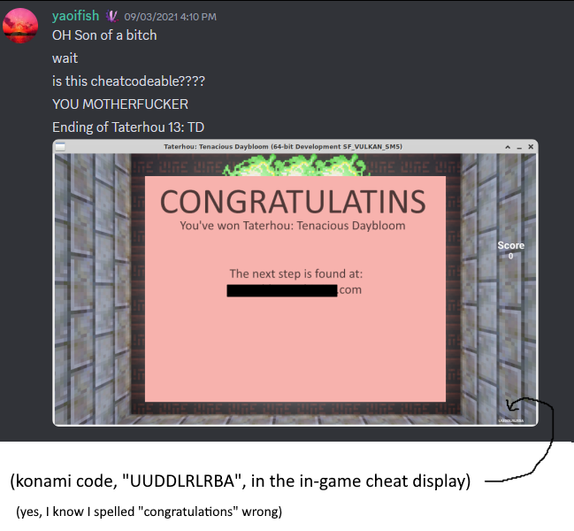
Alwinfy later commented on how they came across it:

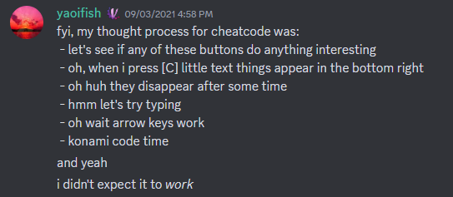

Also, there were a few more cheat codes with special effects. Entering “bnuuy” instantly killed you (referencing the tater/bnuuy war happening at the time). Entering “train” or “yink” made the player character into my personal tatersona if you will which was a combination and Young Link. There were more cheat codes referencing Botania developers/maintainers, but I forgot what they do.

Anyways, with the next step revealed, a user who is no longer in the server entered the link in the screenshot Alwinfy had posted. This redirected them to a series of even more Google Doc puzzles. One of them involved using the number of Rannuncarpus that spawned in Taterhou. Another required the user to check the Twitter account of the previous Tater ARG winner - which is @Niartenotrap (my username spelled backwards).

With the aforementioned no-longer-present user solving the “intended” route of Tater ARG 2, the ARG had been completed.

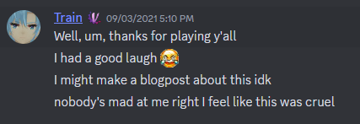

You see, I thought whoever would reach the point in Tater ARG 2 where they had to access an account that had my username spelled backwards would realize that they’d been bamboozled this whole time regarding Tater ARG 1. I thought they would figure it out. I thought at least someone knew. But it was clear they didn’t.

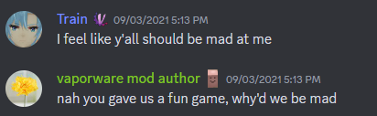
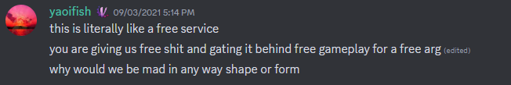

So, at this point, I had to spell it out:

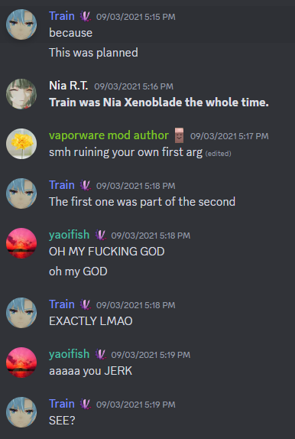

And the reaction was priceless.
I still find myself searching for these particular messages on occasion, I get a kick out of them. Is that messed up?

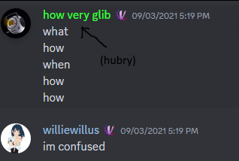

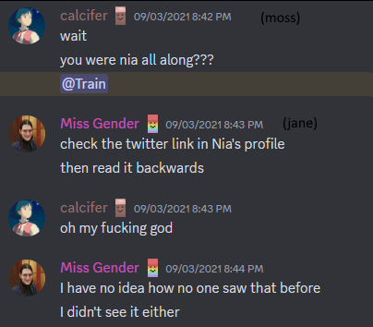

(I did have to un-link the Niartenotrap Twitter from the Nia Discord account when people were investigating the Nia user).

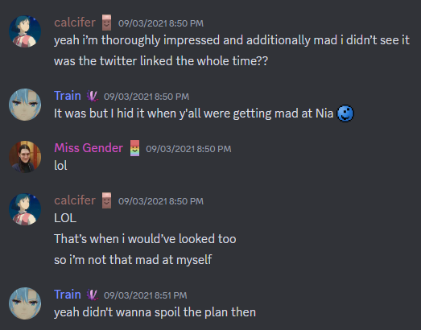

That concluded Tater ARG 2. And my maniacal laughter.

However, I wasn’t quite “done” with Taterhou yet. I thought, hey, why not preserve it, make it marginally more playable, and then put it on Itch.io. Now it’s Taterhou: Tenacious Daybloom Deluxe.

This is the version I would recommend you play now if you’re curious. Warning: it’s still not very fun.
If you’re at all familiar with Unreal Engine and want to see the mess of blueprints Taterhou is, the source project is linked on the Itch.io page as well.

Tater ARG 3 / “La Tatercon”
When making ARG 2, I did want there to be an interactive third ARG. However, it ended up being far less interesting than the last two events, mostly because I felt bad/guilty, I was tired of making ARGs, and I just wanted to get the reward Moriya earned for beating the game I designed to be impossible to him.

So, I resorted to shitposting about “La Tatercon”, or LTC as I liked to call it. LTC was a real life event - a Smash tournament in Round Rock, Texas that I was going to named Low Tide City.

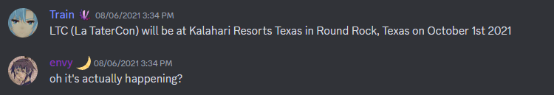

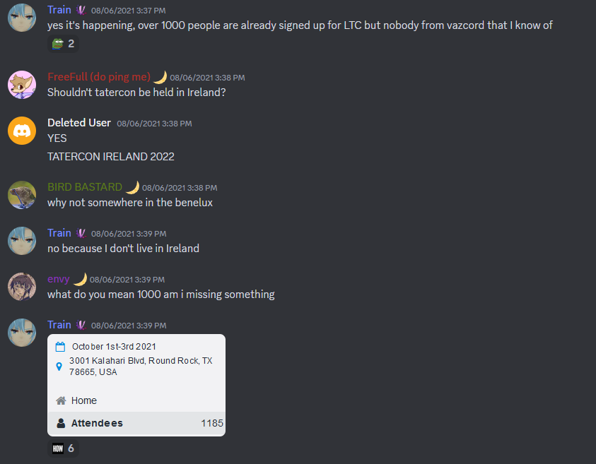

This was, of course, me injecting my other hyperfixation at the time (Competitive Smash) into Tiny Potato. It was more clearly a joke though. In actuality, I had given the real Tater Crate to MoriyaShiine before this, and only told him to “announce it” on the day of this supposed La Tatercon.

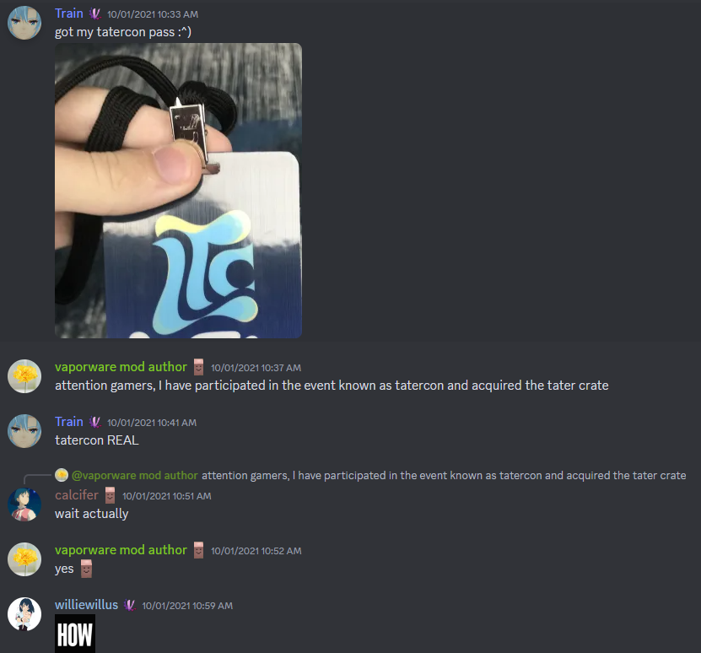

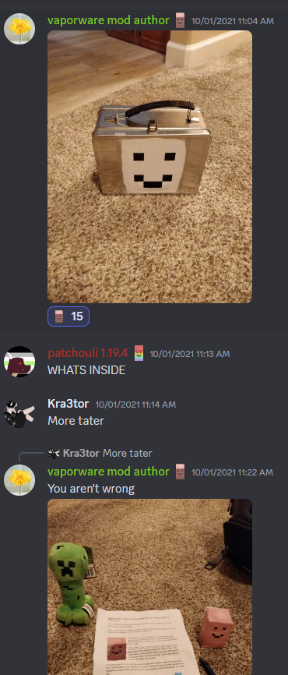
Here is the full-size image of the contents of the crate:

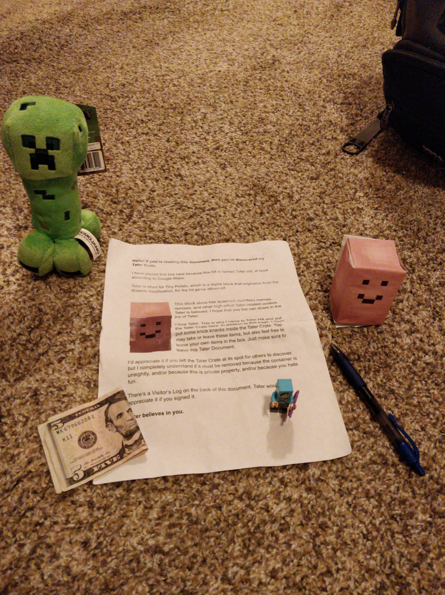

The original document printed on the paper can be found beside this file at “tater_crate_document.pdf”.
The template for the papercraft Tiny Potato can be found beside this file at “Papercraft_Tater.pdf”.

And the reaction to the final chapter of the Tater ARG saga:

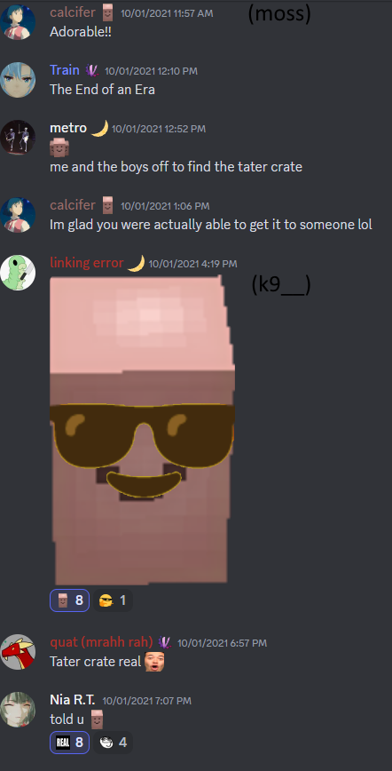

TL;DR
I gaslit this server for a month into playing a terrible unwinnable game I made, and the winner was rewarded.

Other Tater Projects
There were occasionally more high-effort tater shitposts. The last one that I made was when I streamed Twitch Plays Pokemon Pink: Special Tater Edition for April Fool’s Day 2023. This Twitch clip really speaks for itself. I imagine there will be more, if I can think of them.

Conclusion

Tater has since waned as a meme topic, but it remains as the mascot of Violet Moon. It proceeded to graduate from college and enter a fulfilling career in botany and agriculture.

Still, the Tater ARG officially never happened. If anyone ever asks you what the Tater ARG was, tell them they are crazy.

